**Lab 0: Access your AWS Academy Canvas - Resource Setup**

Brandon Trinkle

Information Technology, Arizona State University

IFT 320: Class Name

Professor Rahul Kashyap

8/28/2024

**Lab X: APA Example (Repeat title)**

**Figure 1**

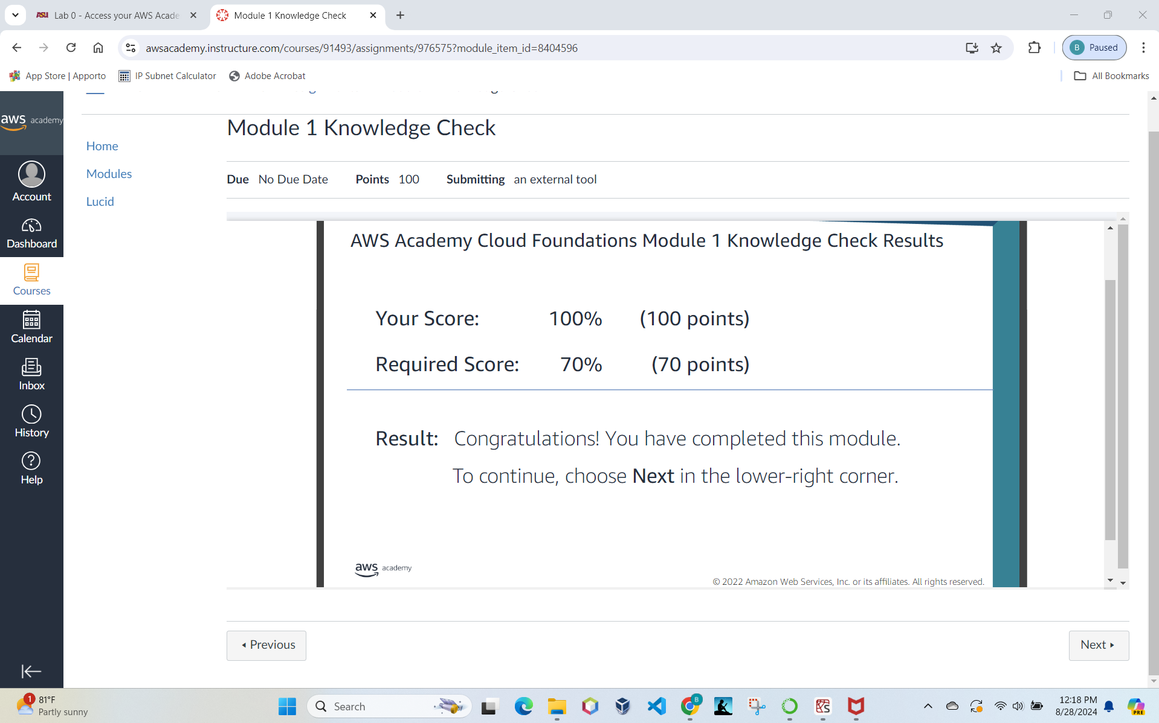

*Note*. AWS Academy Cloud Foundations quiz result.

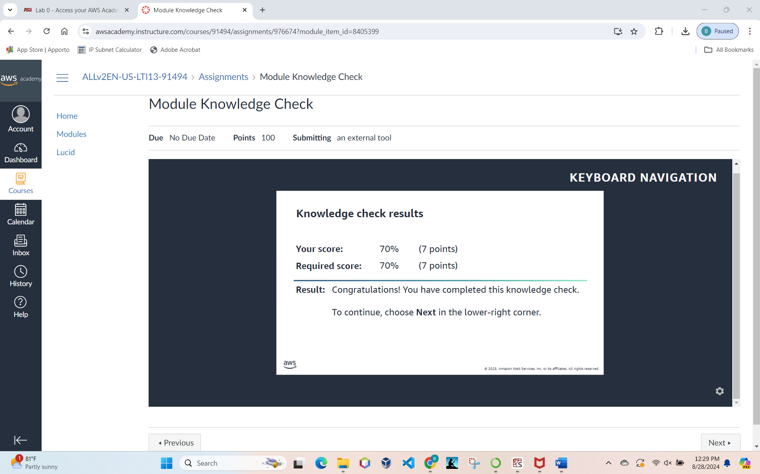

*Note*. AWS Academy Learner Lab result.

**Figure 2**

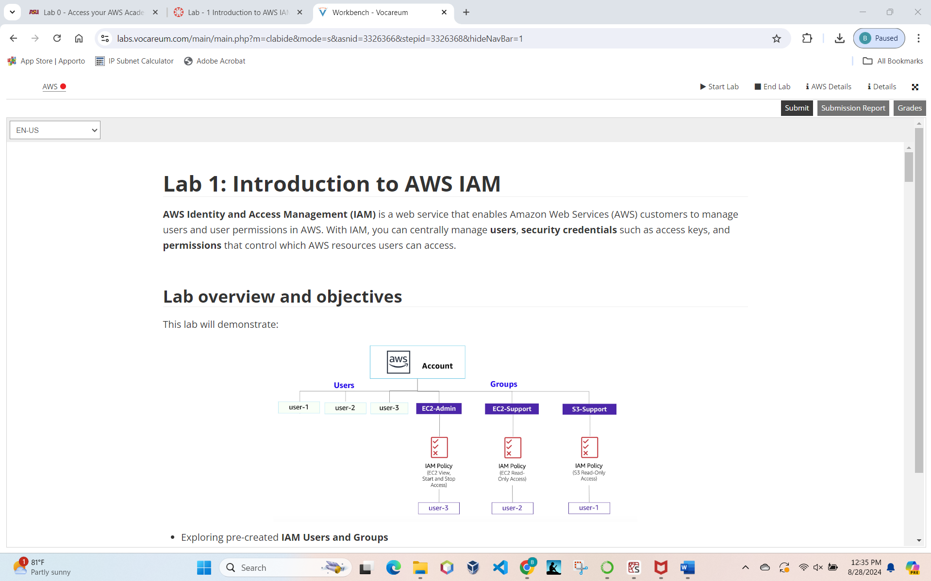 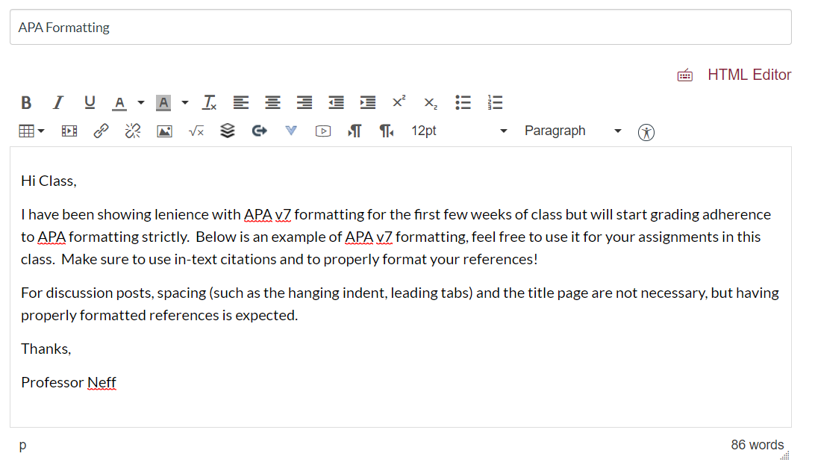

*Note*. Access to Lab 1 - Introduction to IAM" on Module 4 of the AWS Academy LMS.